Supplementary Figure A1
Titanite BSE maps from sample 20-GS-6001-A1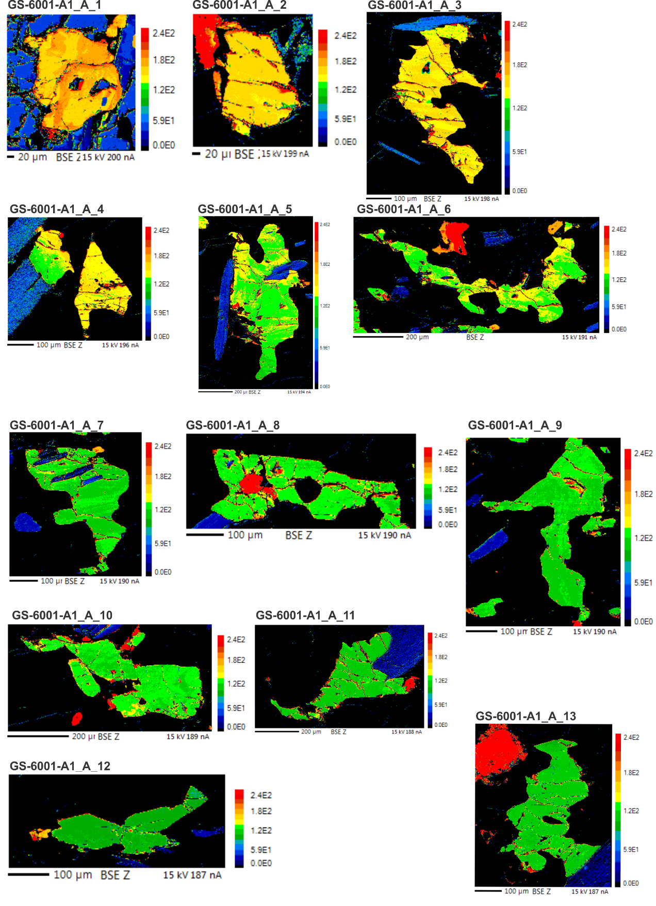
Titanite BSE maps for sample 20-GS-6001-G1