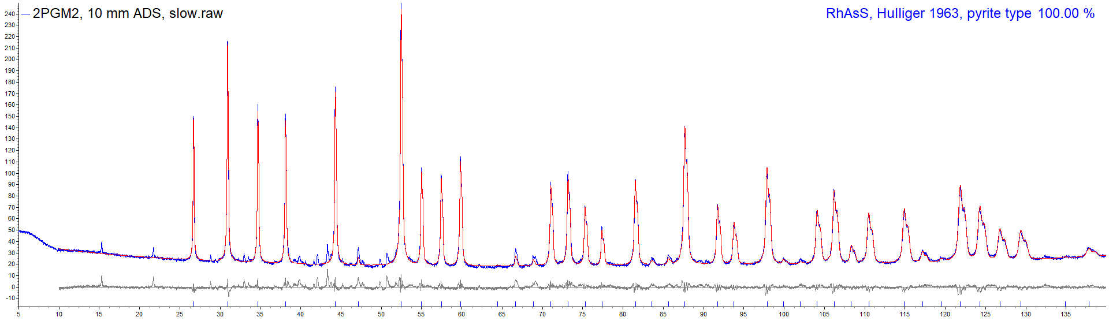

Fig. S1. Powder X-ray diffraction pattern of the RhAsS sample (sample 2PGM-2).

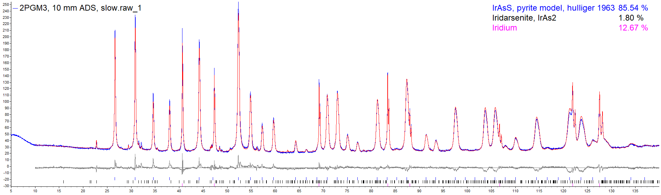

Fig. S2. Powder X-ray diffraction pattern of the IrAsS sample (sample 2PGM-3).

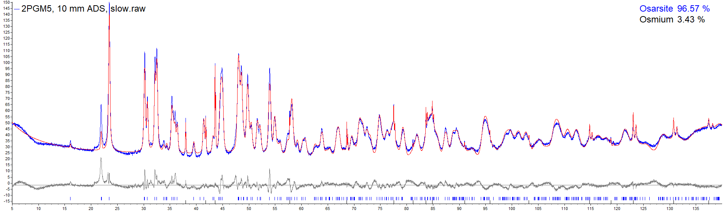

Fig. S3. Powder X-ray diffraction pattern of the OsAsS sample (sample 2PGM-5).

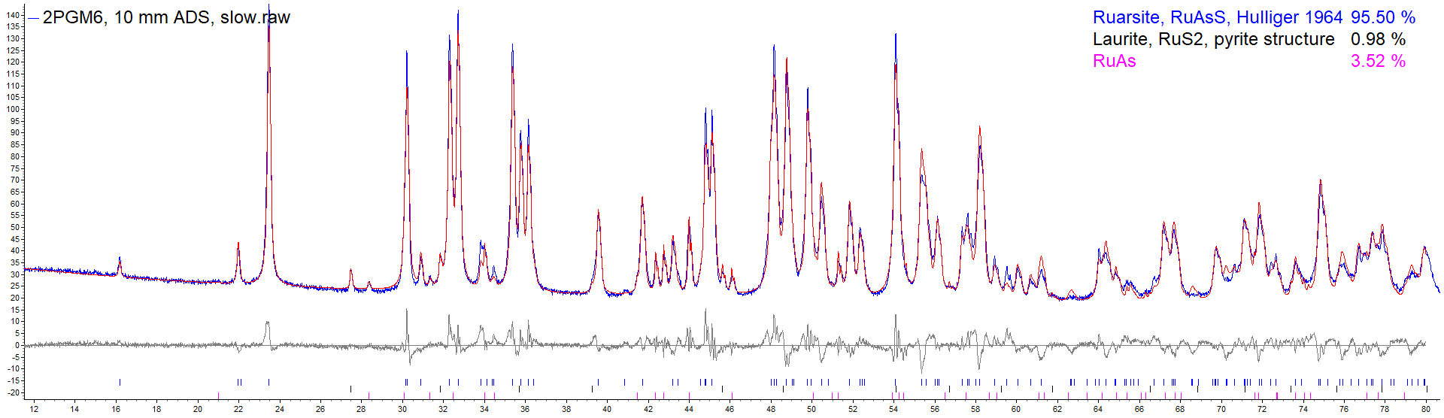

Fig. S4. Powder X-ray diffraction pattern of the RuAsS sample (sample 2PGM-6).

