Supplementary Material for:

Tectono-metamorphic evolution of the Jura-Cretaceous Kluane Basin, Southwest
Yukon

Will McKenzie¹, Brendan Dyck², H. Daniel Gibson¹ & Matthew Steele-MacInnis³

- Department of Earth Sciences, Simon Fraser University, Burnaby, BC, Canada
- Department of Earth, Environmental and Geographical Sciences, University of British Columbia, Kelowna, BC, Canada
- Department of Earth and Atmospheric Sciences, University of Alberta, Edmonton, AB, Canada

Supplementary figures:

- Figure S1: Ramen spectrum of graphite inclusions within garnet in sample 19WM118 (zone 6). The D1-band and G-band are highlighted. Based on the relative integrated intensities of the two latter Raman bands and using the calibration equation provided by Beyssac et al. (2002), we obtain temperature estimates ranging from 500 to 630 °C.

- Figure S2: Result from petrological modelling with ds5.5 and aH₂O = 1 across the entire P-T range considered. Activity models used are described in main text. All mineral abbreviations from Holland and Powell (1998), except for: qtz = quartz; L = liquid (melt). The resulting phase diagram is unable to produce the assemblage that characterizes zone 5a (bt-grt-pl-qtz-and). Individual reactions are not labelled as in the main publication, instead the first predicted appearance of individual index minerals is highlighted with coloured dashed lines. This result highlights that defining an inaccurate water activity predicts the appearance of cordierite prior to aluminium silicate, a relationship not observed across the Kluane Schist.

- Figure S3: Result from petrological modelling when using the modified SPaC14 dataset of Spear & Cheney (1989) and activity models as described in Pattison & Debuhr (2015); aH₂O = 1 across the entire P-T range considered. All mineral abbreviations from Whitney and Evans (2010), except for: qtz = quartz; L = liquid (melt); ru = rutile. The resulting phase diagram is unable to produce the assemblages that characterise zones 5a/b (bt-grt-pl-qtz-and/sill) and structurally higher regions of zone 6 (crd-bt-grt-pl-qtz). Individual reactions are not labelled as in the main publication, instead the first predicted appearance of individual index minerals is highlighted with coloured dashed lines. Correctly predicted assemblages do not align with results from AvP, conventional barometry and ramen spectroscopy (e.g., zones 3 & 4 are predicted at much higher P). Further, the relationship, in terms of predicted P-T, between zones suggested by the phase diagram is not supported by petrographic analysis.

- Figure S4: Result from petrological modelling with ds6.2 and aH₂O = 1 across the entire P-T range considered. Activity models used are described in main text. All mineral abbreviations from Holland and Powell (2011), except for: qtz = quartz; L = liquid (melt). The resulting phase diagram is unable to produce the assemblages characteristic of zones 2b (zo-chl-ms-pl-qtz-ru), 5a (bt-grt-pl-qtz-and) and the structurally higher regions of zone 6 (crd-bt-grt-pl-qtz). Individual reactions are not labelled as in the main publication, instead the first predicted appearance of individual index minerals is highlighted with coloured dashed lines. Correctly predicted assemblages do not align with results from AvP, conventional barometry and Ramen Spectroscopy (e.g., zones 2b & 6 are predicted at much higher P). Overall, the relationship between assemblage P-T predicted by this modelling combination is not supported by our petrographic analysis.

- Figure S5: Isobaric T-XH₂O diagrams for the average bulk composition of the Kluane Schist. Green dashed lines show the minimum amount of H₂O required to saturate the system at the solidus (red dashed line) at (a) 4.0 kbar and (b) 2.0 kbar.

- Figure S6: a) Thin section image highlighting the location of calcite inclusions within the core of the analysed garnet. b-c) PPL (b) and XPL (c) thin section images of calcite inclusions within the garnet core (red box in (a)). d) Ramen spectrum identifying calcite inclusions within garnet (host) in sample 19WM118 (zone 6).

Supplementary tables:

- Table S1: Bulk rock chemistry determined by X-ray fluorescence.
- Table S2: Garnet mineral compositions determined by electron microprobe.
- Table S3: Muscovite mineral compositions determined by electron microprobe.
- Table S4: Chlorite mineral compositions determined by electron microprobe.
- Table S5: Cordierite mineral compositions determined by electron microprobe.
- Table S6: Staurolite mineral compositions determined by electron microprobe.
- Table S7: Biotite mineral compositions determined by electron microprobe.
- Table S8: Plagioclase mineral compositions determined by electron microprobe.
- Table S9: Summary of garnet compositional profiles.

Figure S1:

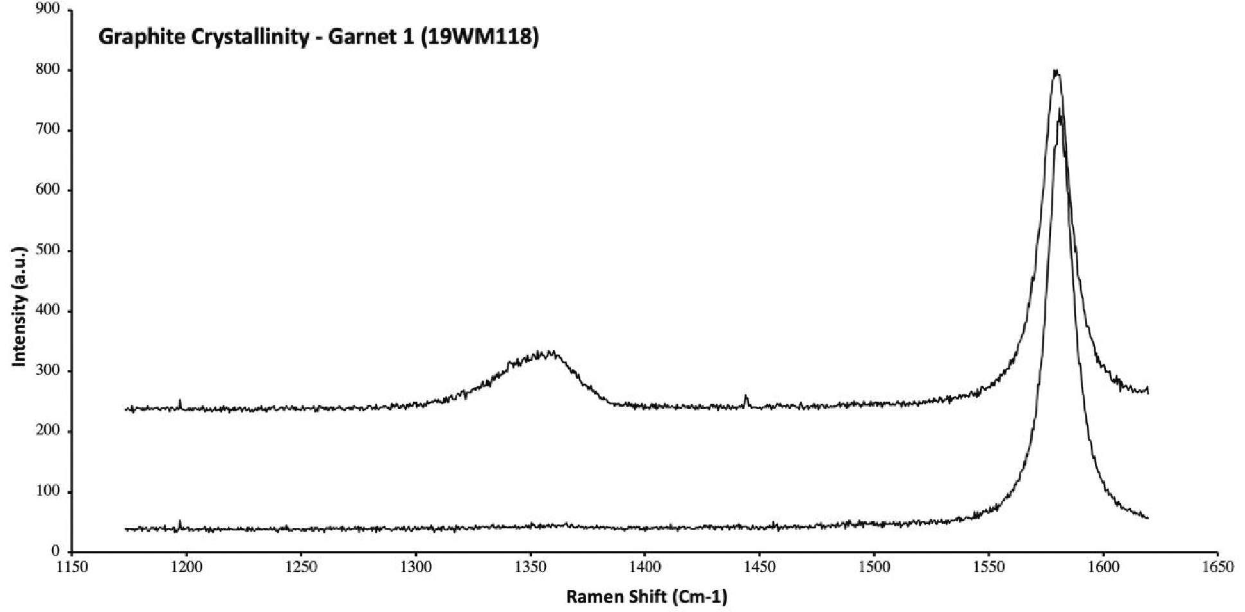
D1-band
G-band

Figure S2:

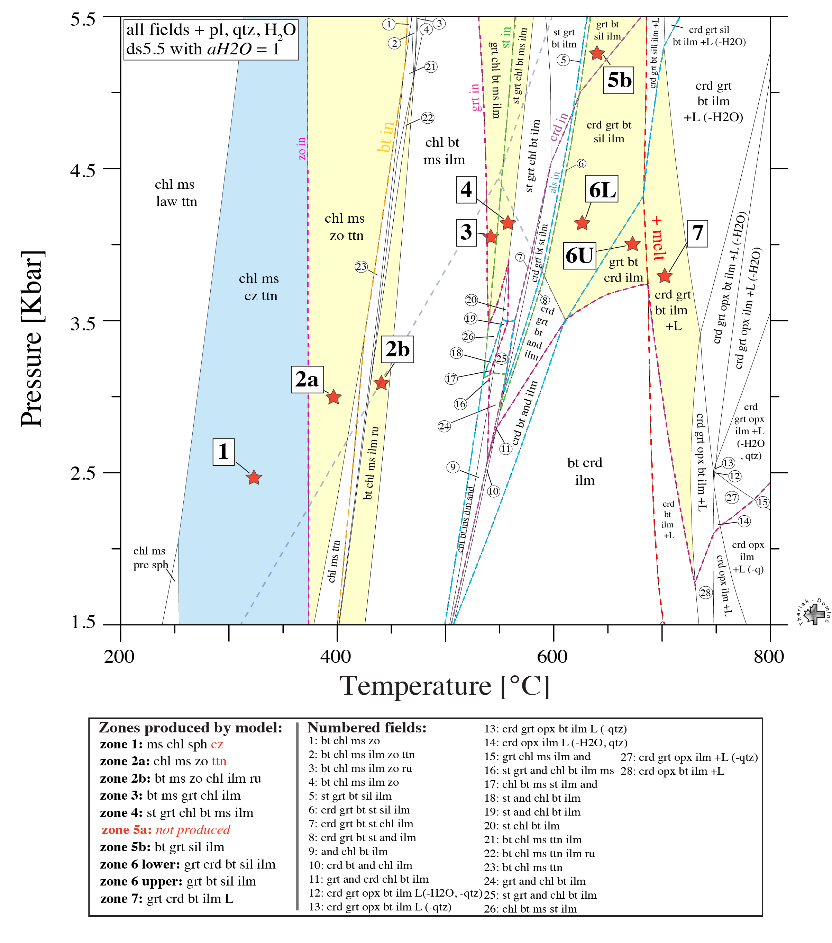

Figure S3:

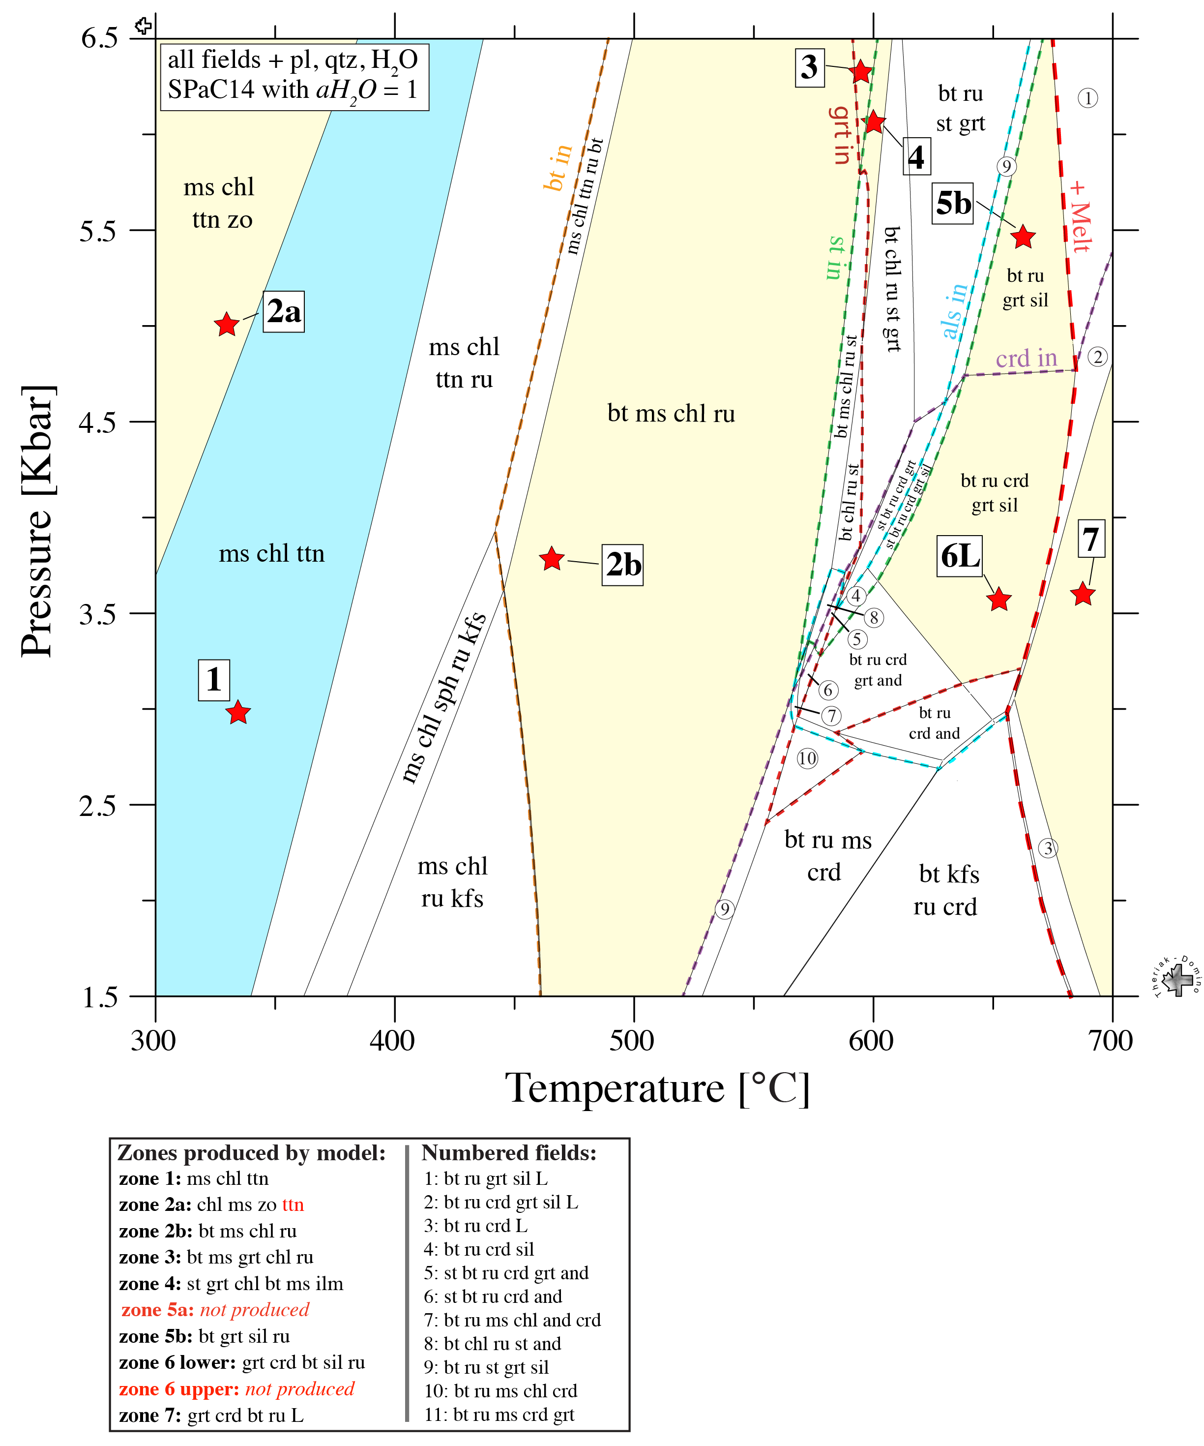

Figure S4:
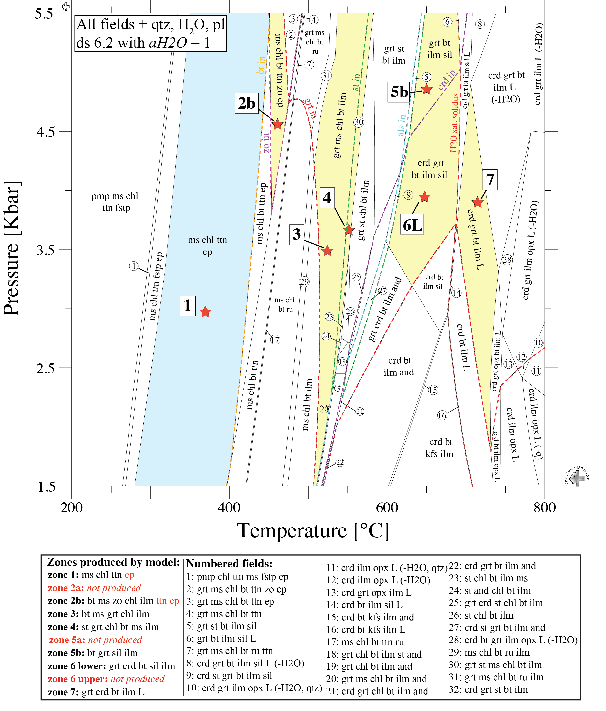
Figure S5:

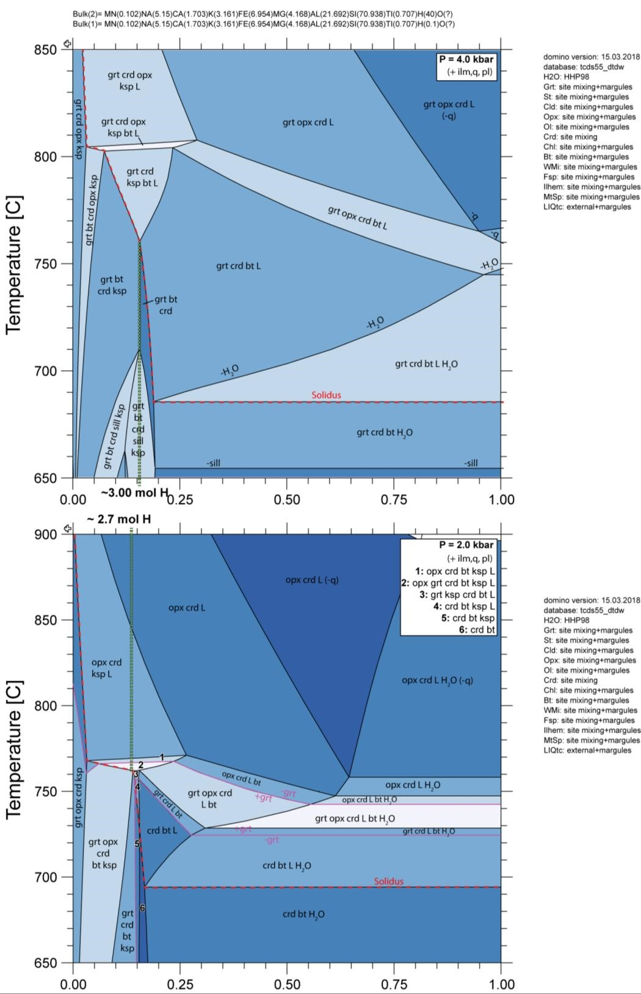

Figure S6:

