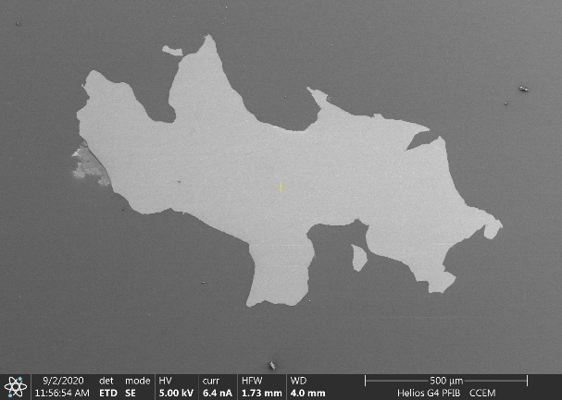  (a) | 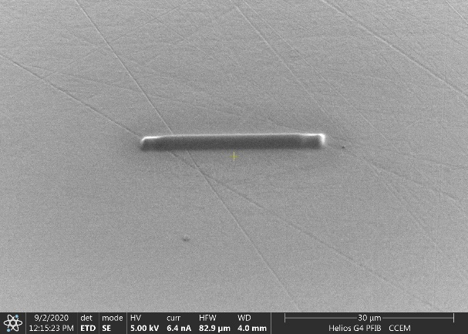  (b)
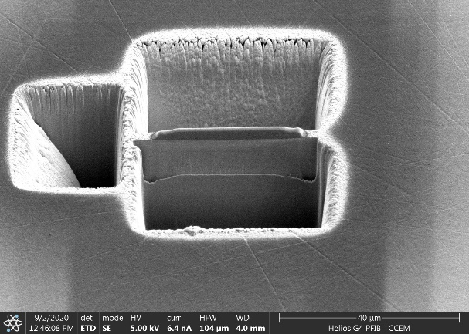  (c) | 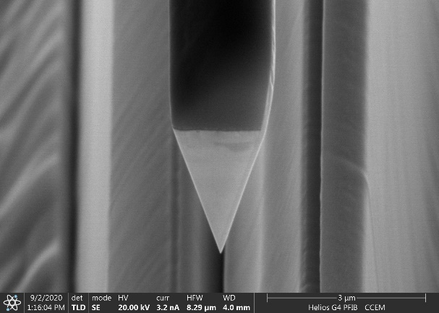  (d)
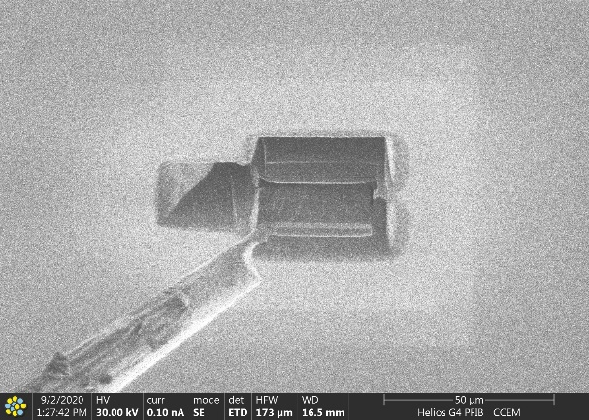  (e) | 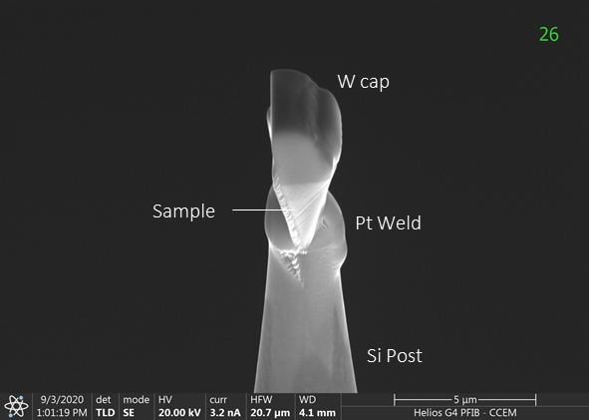  (f)
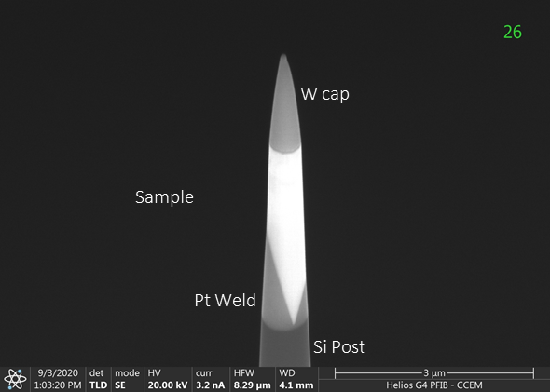  (g) | 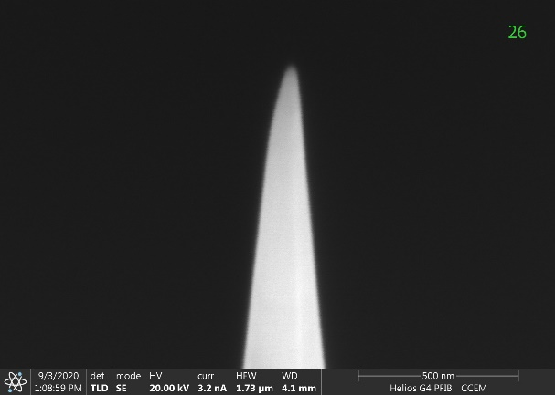  (h)
Suppl. Figure 1. APT sample preparation for Preston sample, showing liftout process and typical sample sharpening using Xe plasma FIB. Images show the following: (a) Liftout location, (b) protective W deposition, (c) trench cuts around ROI, (d) cantilever sample prior to liftout, (e) extraction using micro-manipulator, (f) sample mounted on Si micropost, (g) sample during annular milling, (h) sample after final sharpening.

