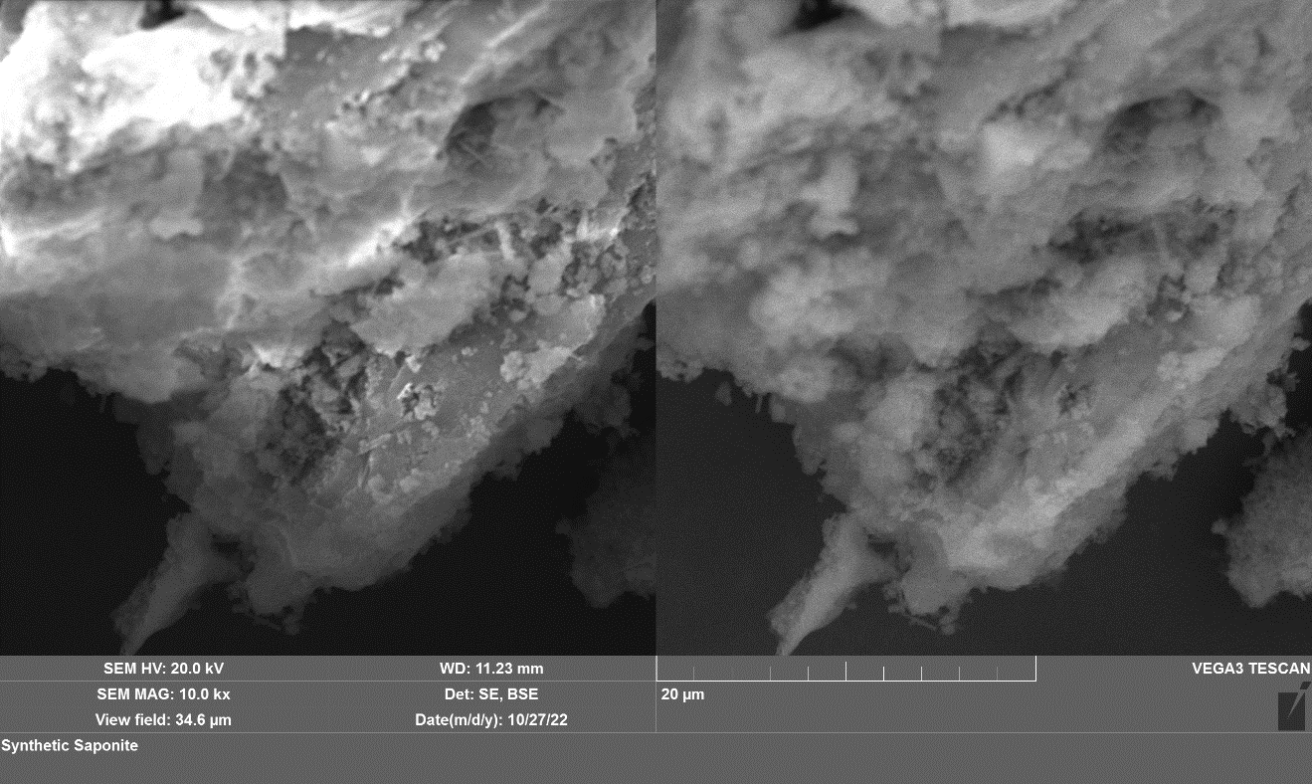
Appendix A. SEM images of the synthetic saponite as a starting material before experiments. A secondary electron (SE) image is on the left side, and a backscattered electron (BSE) image is on the right side.

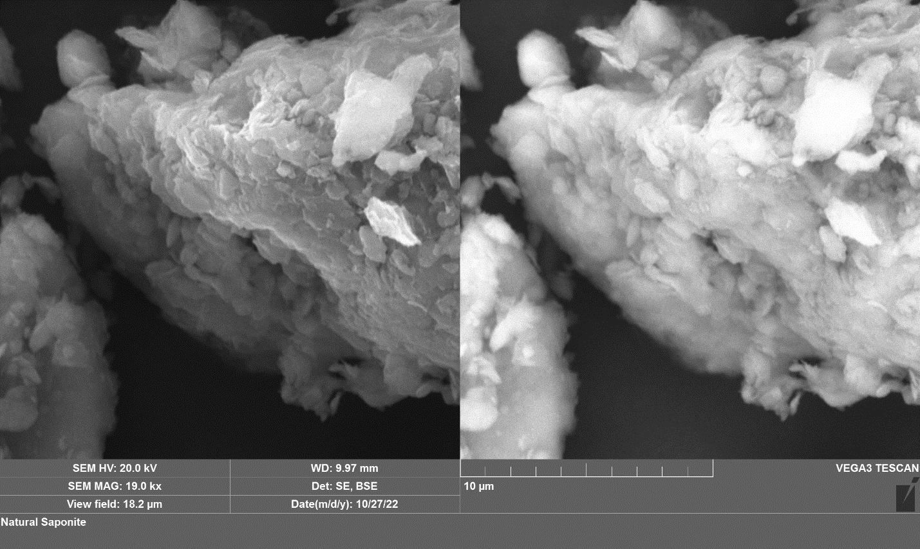
Appendix B. SEM images of the natural saponite as a starting material before experiments. A secondary electron (SE) image is on the left side, and a backscattered electron (BSE) image is on the right side.

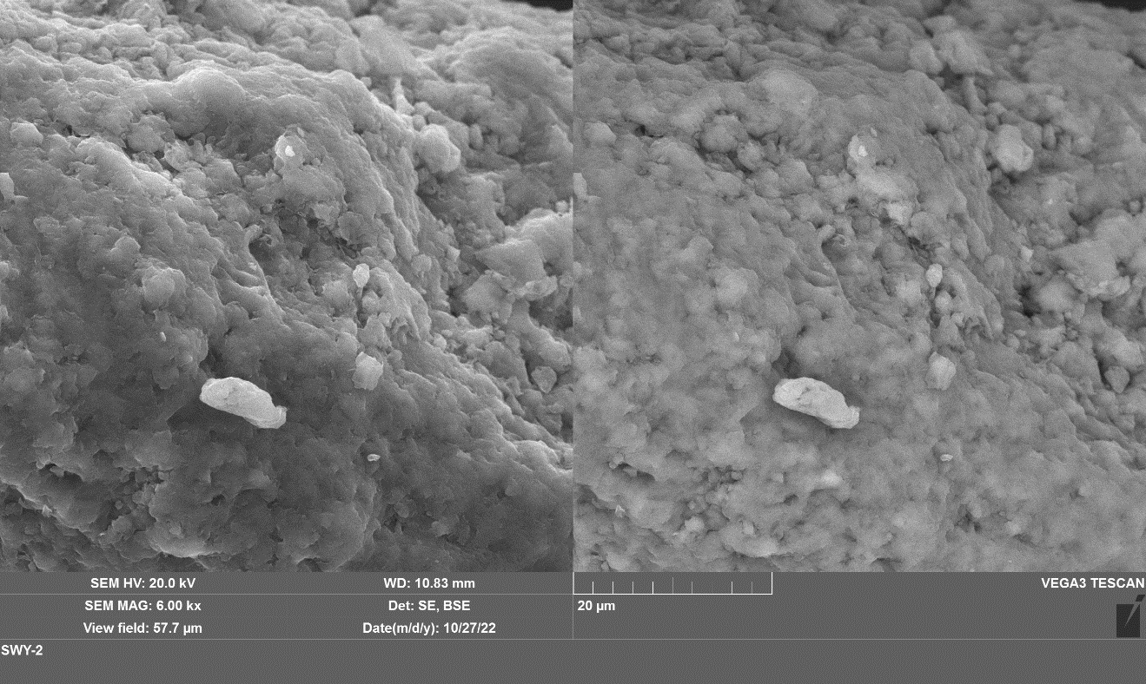
Appendix C. SEM images of the as-received Wyoming montmorillonite (Swy-2) as a starting material before experiments. A secondary electron (SE) image is on the left side, and a backscattered electron (BSE) image is on the right side.

