Appendix A. Trace element compositions of ore samples from the Maoping deposit

1 Samples and analytical method

14 ore samples in this study were obtained from the borehole and tunnel of the Maoping deposit. These samples, which are mainly composed of sphalerite, galena, and pyrite, have dense massive structure (Fig. A1).

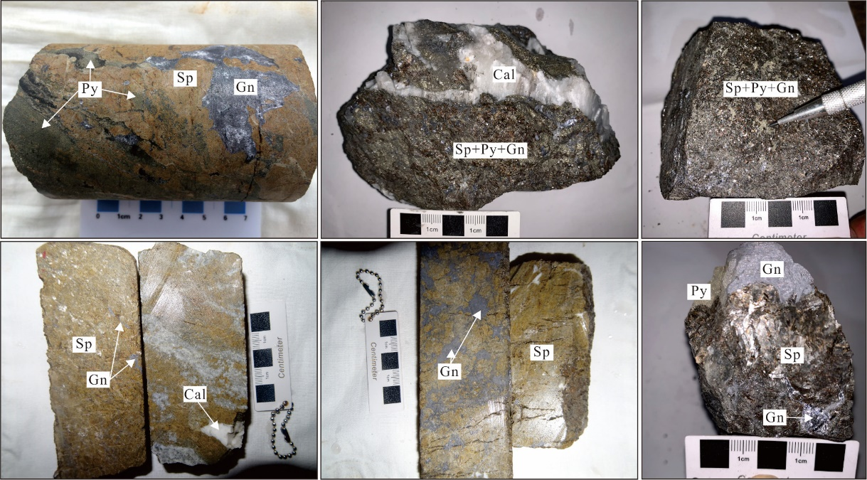
Fig. A1. Typical ore samples from the Maoping Zn-Pb deposit. Py = Pyrite; Sp = Sphalerite; Gn = Galena; Cal = Calcite.

The samples were ground to 200 mesh by agate mortar in a pollution-free environment and completed by Testing Center of Northwest Nonferrous Geological Research Institute, Xi'an, China. Zn and Pb were analyzed by plasma emission spectrometer (ICP-OES) and the detection limit was 10⁻⁶. Ga, Ge, Cd, and In were tested by plasma mass spectrometer (ICP-MS) and the detection limit was 10⁻⁹. The relative error of the analysis result is better than 5%.

2 Results

Trace element compositions of ore samples from the Maoping Zn-Pb deposit

Sample number | Zn (wt%) | Ga (ppm) | Ge (ppm) | Cd (ppm) | In (ppm) | Pb (wt%)
KHc-07 | 10.95 | 18.7 | 72.9 | 1850 | 2.28 | 10.99
KHc-13 | 10.85 | 4.83 | 34.6 | 416 | 0.07 | 14.85
BK01-26 | 17.83 | 1.95 | 106 | 1320 | 0.04 | 15.47
KHc-6 | 15.61 | 2.26 | 24.0 | 314 | 2.58 | 9.88
92-1Zc48 | 17.46 | 1.60 | 42.9 | 497 | 0.13 | 24.48
92-1Zc50 | 11.53 | 0.59 | 34.6 | 195 | 0.05 | 21.93
I-7 | 13.71 | 0.83 | 43.8 | 381 | 2.25 | 18.11
KG58-4 | 18.24 | 1.82 | 75.6 | 828 | 0.01 | 5.58
92-1-ZC41 | 13.33 | 1.76 | 78.7 | 372 | 0.06 | 24.40
92-1-ZC42 | 17.62 | 5.76 | 56.0 | 382 | 7.27 | 15.11
92-1-ZC43 | 23.92 | 5.59 | 41.9 | 763 | 0.46 | 11.55
92-1-ZC45 | 18.98 | 2.02 | 64.1 | 516 | 0.01 | 14.82
92-1-ZC48 | 17.35 | 3.93 | 75.7 | 728 | 0.20 | 23.99
110-2-KZ10 | 19.45 | 3.33 | 49.8 | 669 | 3.02 | 2.47

